Section I: Scenario Demographics

Scenario Title: | Kicked off a Horse – Pelvic Fracture and SDH
Date of Development: | 20/06/2015 (DD/MM/YYYY)
Target Learning Group: | Juniors (PGY 1 – 2) Seniors (PGY ≥ 3) All Groups

Section II: Scenario Developers

Scenario Developer(s): | Kyla Caners
Affiliations/Institution(s): | McMaster University
Contact E-mail (optional): | kcaners@gmail.com

Section III: Curriculum Integration

Learning Goals & Objectives
Educational Goal: | To enhance resuscitation and team management skills through a trauma scenario with multiple key steps.
CRM Objectives: | - Effectively lead a trauma team and delegate roles appropriately.  - Communicate clearly as a team in a complex scenario
Medical Objectives: | - Perform safe and thorough primary survey.  - Demonstrate safe approach to intubating a head-injured trauma patient.  - Recognize and manage unstable pelvic fracture and FF in abdomen  - Administer PRBCs.  - Administer TXA.  - Apply pelvic binder.  - Consult orthopedics and general surgery for definitive management.

Case Summary: Brief Summary of Case Progression and Major Events
A 32-year-old female presents after being bucked off of her horse. She is brought in as a trauma team activation because of a low BP. Her primary survey will reveal a boggy hematoma over her right temporal area as well as an unstable pelvis. Her initial GCS will be 8. The team will proceed through airway management in a hypotensive, head-injured trauma patient while also binding her pelvis.

References
Marx, J. A., Hockberger, R. S., Walls, R. M., & Adams, J. (2013). Rosen's emergency medicine: Concepts and clinical practice. St. Louis: Mosby.

Section IV: Scenario Script

A. Scenario Cast & Realism
Patient: | Computerized Mannequin |  |  |  |  | Realism:  Select most important dimension(s) |  |  | Conceptual
 | Mannequin |  |  |  |  |  |  |  | Physical
 | Standardized Patient |  |  |  |  |  |  |  | Emotional/Experiential
 | Hybrid |  |  |  |  |  |  |  | Other:
 | Task Trainer |  |  |  |  |  |  |  | N/A
Confederates | Brief Description of Role
None.
B. Required Monitors
EKG Leads/Wires |  |  | Temperature Probe |  |  |  | Central Venous Line
NIBP Cuff |  |  | Defibrillator Pads |  |  |  | Capnography
Pulse Oximeter |  |  | Arterial Line |  |  |  | Other:
C. Required Equipment
Gloves |  |  | Nasal Prongs |  |  |  | Scalpel
Stethoscope |  |  | Venturi Mask |  |  |  | Tube Thoracostomy Kit
Defibrillator |  |  | Non-Rebreather Mask |  |  |  | Cricothyroidotomy Kit
IV Bags/Lines |  |  | Bag Valve Mask |  |  |  | Thoracotomy Kit
IV Push Medications |  |  | Laryngoscope |  |  |  | Central Line Kit
PO Tabs |  |  | Video Assisted Laryngoscope |  |  |  | Arterial Line Kit
Blood Products |  |  | ET Tubes |  |  |  | Other: Blanket to bind pelvis
Intraosseous Set-up |  |  | LMA |  |  |  | Other:
D. Moulage
Boggy hematoma to right temporal area. Dirty, torn clothes. Boarded and collared on arrival.

E. Approximate Timing
Set-Up: |  | 10 min |  | Scenario: | 12 min |  |  | Debriefing: |  | 20 min

Section V: Patient Data and Baseline State

A. Clinical Vignette: To Read Aloud at Beginning of Case
A 32-year-old female presents as a trauma activation with EMS after being bucked off of her horse. Her mom witnessed the episode and called EMS because she seemed groggy. She has had a low BP with EMS on route. Her current BP is 80/40.
B. Patient Profile and History
Patient Name: Jennifer Starr |  |  |  |  |  | Age: 32 |  |  |  |  |  |  |  | Weight: 65kg
Gender: M F |  |  |  |  |  | Code Status: Full
Chief Complaint: Bucked off a horse
History of Presenting Illness: Bucked off her horse today. EMS called when patient seems groggy.
Past Medical History: |  | Nil. |  |  |  |  | Medications: |  |  |  |  | OCP.
Allergies: None.
Social History: Horse trainer. Lives on a farm outside the city.
Family History: N/A
Review of Systems: |  | CNS: |  |  | No voiced complaints (unable).
 |  | HEENT: |  |  | No voiced complaints (unable).
 |  | CVS: |  |  | No voiced complaints (unable).
 |  | RESP: |  |  | No voiced complaints (unable).
 |  | GI: |  |  | No voiced complaints (unable).
 |  | GU: |  |  | No voiced complaints (unable).
 |  | MSK: |  |  | No voiced complaints (unable). |  |  |  |  |  |  |  | INT: |  | No voiced complaints.
C. Baseline Simulator State and Physical Exam
No Monitor Display |  |  |  | Monitor On, no data displayed |  |  |  |  |  |  | Monitor on Standard Display
HR: 120/min |  |  | BP: 80/40 |  |  |  |  | RR: 22/min |  |  |  |  |  |  | O₂SAT: 96% RA
Rhythm: sinus tach |  |  | T: 36.1ºC |  |  |  |  | Glucose: 7.1 mmol/L |  |  |  |  |  |  | GCS: 8 (E2 V2 M4)
General Status: GCS 8. Appears unwell.
CNS: | As above. PERLA 3mm.
HEENT: | Boggy hematoma over right temporal area. No other signs HI.
CVS: | No murmur. Normal heart sounds.
RESP: | GAEB. No adventitious. Trachea midline.
ABDO: | Soft, NT.
GU: | Perineal hematoma.
MSK: | Pelvis unstable. |  |  |  |  |  |  |  | SKIN: | Abrasions only.

Scenario States, Modifiers and Triggers
Patient State | Patient Status | Learner Actions, Modifiers & Triggers to Move to Next State
1. Baseline State  Rhythm: sinus tach  HR: 120/min  BP: 80/40  RR: 22/min  O₂SAT: 96%  T: 36.1ºC | GCS 8.  Moaning only. | Learner Actions  - Monitors, 2 large IVs  - Trauma labs (include βHCG), cap sugar (7.1)  - Bolus 1L NS  - Call for blood  - Primary survey  - CXR/Pelvic xray  - FAST to r/o FF (+RUQ)  - Bind pelvis  - Give TXA 1g iv  - Call gen sx/ortho/neurosx | Modifiers  Changes to patient condition based on learner action  - 2L NS BP 85/45, HR 115  Triggers  For progression to next state  - Intubation 2. Intubation  - 5 minutes 3. Hypotension
2. Intubation  Keep vitals same as state prior | Unchanged. | Learner Actions  - Have vasopressor on hand  - Appropriate induction (etomidate or ketamine)  - Paralytic administration  - Inline stabilization  - ± Lidocaine/fentanyl pre-tx  - Post-intubation CXR  - Initiate sedation | Modifiers  - Propofol used BP 60/30  Triggers  - Intubated from State 1  3. Hypotension  - Intubated from State 3  4. Herniation
3. Hypotension  BP 65/35  HR 130  If intubated RR 12 | Patient unchanged from previous state. | Learner Actions  - Call ortho/gen sx  - Bind pelvis (if not yet)  - Administer 2u PRBC  - Consider massive transfusion  - FAST (if not yet done) | Modifiers  - 1 unit PRBC BP 70/35  Triggers  - Intubation 2. Intubation  - 2 units PRBC 4. Herniation
4. Herniation  HR 45  BP 75/45  If not intubated RR 6 (irregular)  If intubated RR 12 | Patient’s vitals reflect herniation. Left pupil blown if learners ask. | Learner Actions  - Intubate (if not yet done)  - Hyperventilate patient  - HOB to 30 degrees  - Hypertonic saline 100ml iv  - Mannitol 500ml iv  - Call neurosurgery | Modifiers  Triggers  - 3 interventions to reduce ICP 5. Resolution
5. Resolution  HR 70  BP 90/60 | Unchanged | Learner Actions  - Call neurosurgery  - Facilitate conversation with neurosurgery/gen sx/ortho re: priorities for OR vs. CT vs. IR for embolization | Neurosurgery arrives END CASE
Section VI: Scenario Progression

Section VII: Supporting Documents, Laboratory Results, & Multimedia

Laboratory Results
No blood work given in this case.
Images (ECGs, CXRs, etc.)
ECG – sinus tachycardia  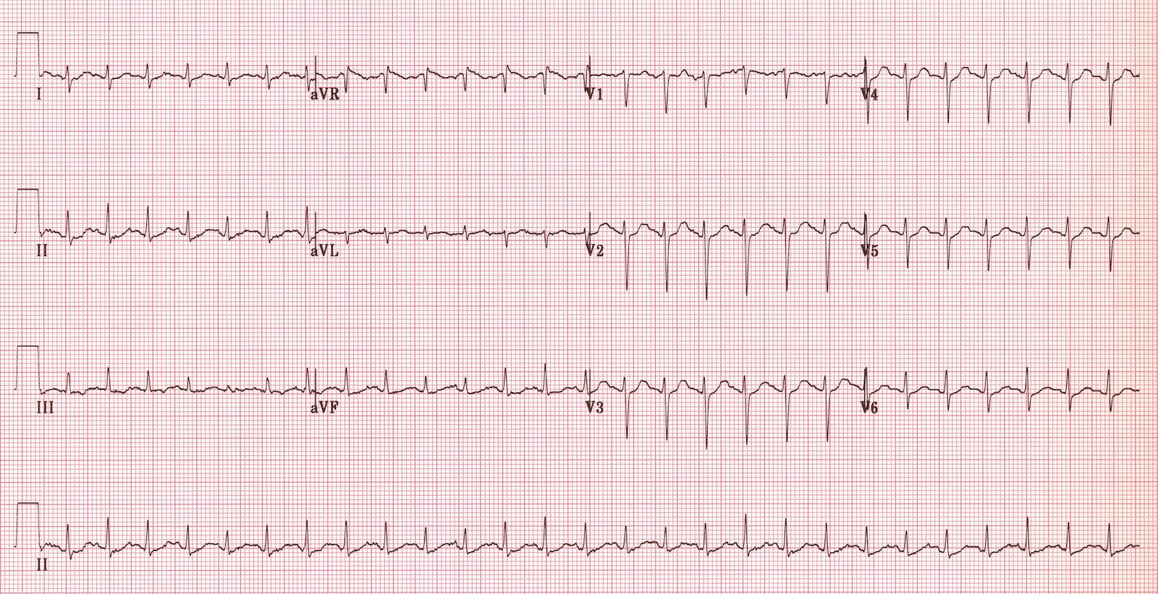  ECG source: https://i0.wp.com/lifeinthefastlane.com/wp-content/uploads/2011/12/sinus-tachycardia.jpg | CXR – pre-intubation  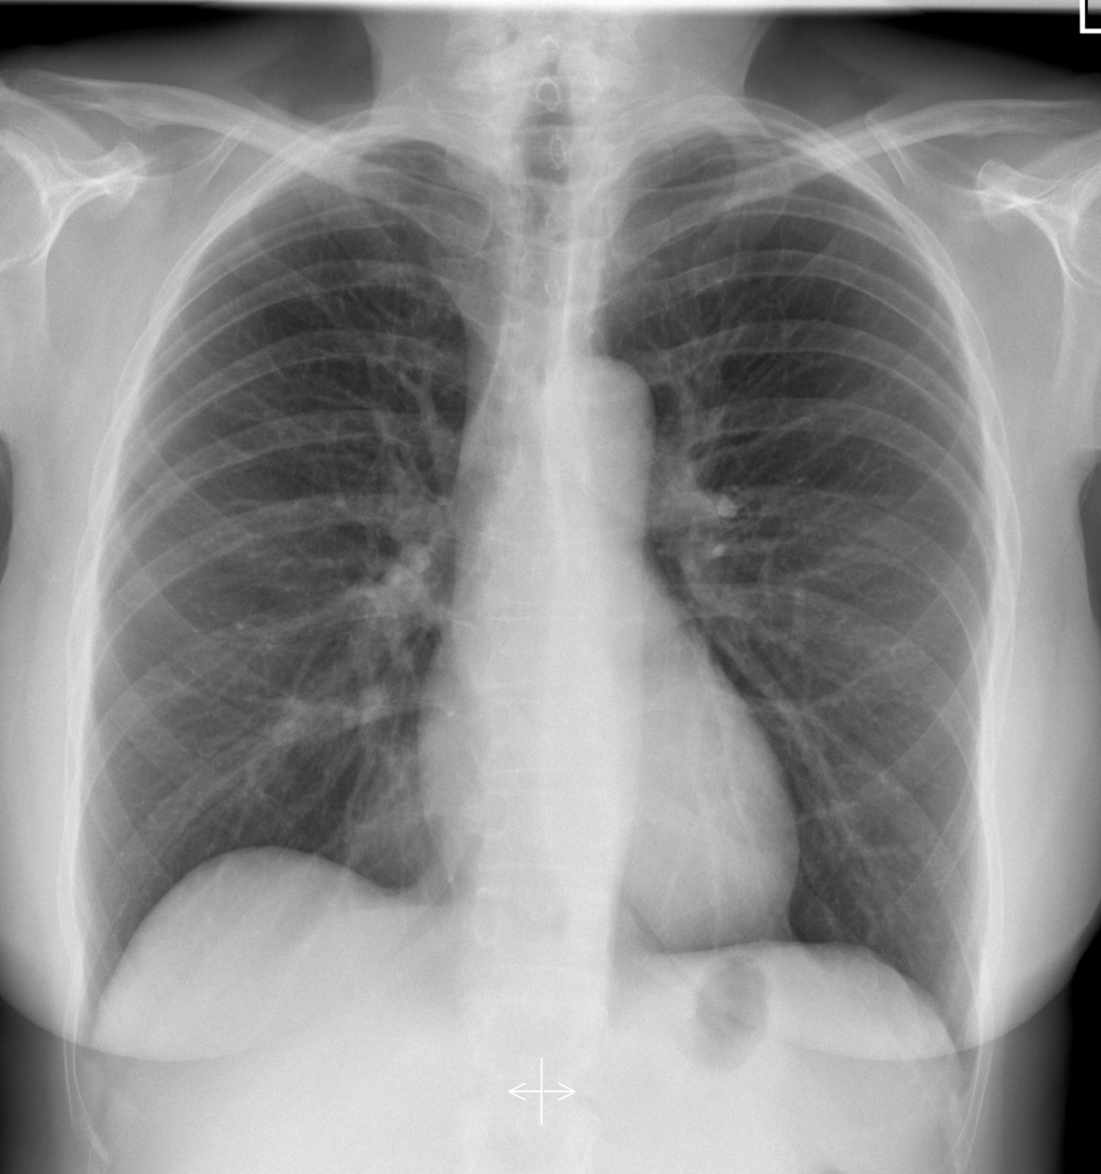  CXR source: https://radiopaedia.org/cases/normal-chest-radiograph-female-1
Pelvic x-ray – fracture shown  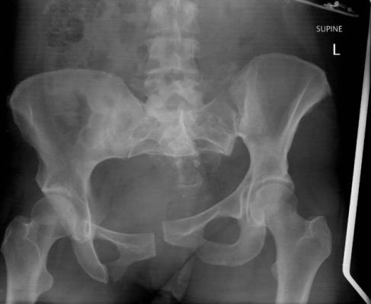  PXR source: https://littlemedic.files.wordpress.com/2013/01/pelvis_0_1.jpg | CXR – post-intubation  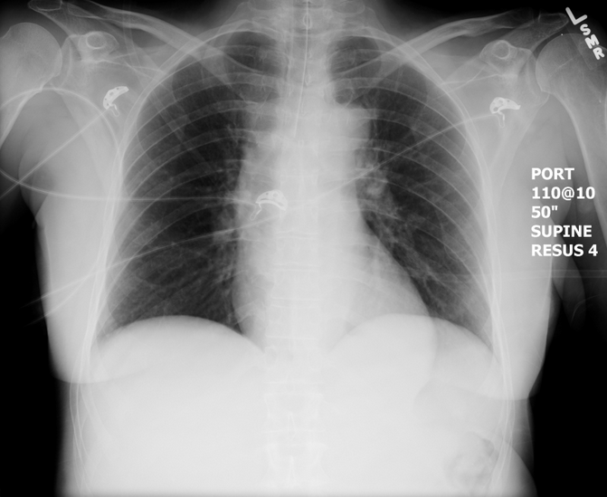  CXR source: https://emcow.files.wordpress.com/2012/11/normal-intubation2.jpg
Ultrasound Video Files (if applicable)
U/S showing FF RUQ | U/S showing no PCE
U/S showing normal lung sliding bilaterally

Section VIII: Debriefing Guide

General Debriefing Plan
Individual | Group |  | With Video | Without Video
Objectives
Educational Goal: |  | To enhance resuscitation and team management skills through a trauma scenario with multiple key steps.
CRM Objectives: |  | - Effectively lead a trauma team and delegate roles appropriately.  - Communicate clearly as a team in a complex scenario
Medical Objectives: |  | - Perform safe and thorough primary survey.  - Demonstrate safe approach to intubating a head-injured trauma patient.  - Recognize and manage unstable pelvic fracture and FF in abdomen  - Administer PRBCs.  - Administer TXA.  - Apply pelvic binder.  - Consult orthopedics and general surgery for definitive management.
Sample Questions for Debriefing
- How do you feel that your team handled the primary survey (initial assessment)?
- Do the team members feel that, as a group, you responded well to a very dynamic, unstable patient?
  - If not, what suggestions can you think of to improve team cohesion and management?
- What is your approach to intubating a head-injured patient? What does “neuro-protective RSI” traditionally include? Did you consider this? What are the key priorities when intubating a head-injured patient?
- What is permissive hypotension? Did you use it in this case? When should we not use it?
- How did it feel having to coordinate so many priorities at once? Do you have a strategy for managing patients with multiple simultaneous priorities?
Key Moments
Recognition of need to intubate
Recognition of herniation
Management of hypotension in context of pelvic fracture and free fluid in abdomen

